** Design Document Guideline**

**Apartment System**

Version 1.3

Prepare by

Narawit Kaewbun

2/November/2016

**1.Revision History**

**2.Use Case Overview**

**Use Case Diagram Level 0 : Management System**

Management Sub - System

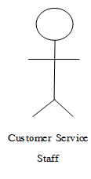

**Use Case Diagram Level 1 : Customer Management System**

Customer Management Sub - System

Customer Service

Staff

4.1 **Static Structure and Data Analysis**

**Insert Customer**

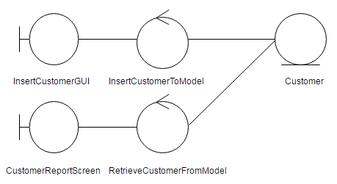

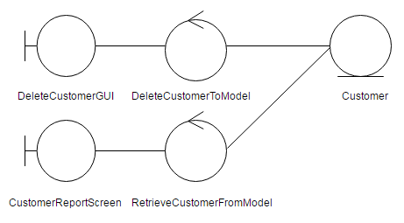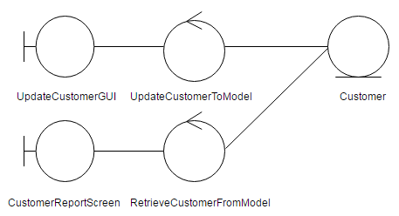 Update Customer

Delete Customer

Report Customer

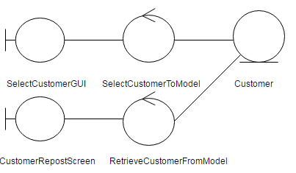

5.System Behavior Model

## Sequence Diagram demonstrating operation “add new customer”

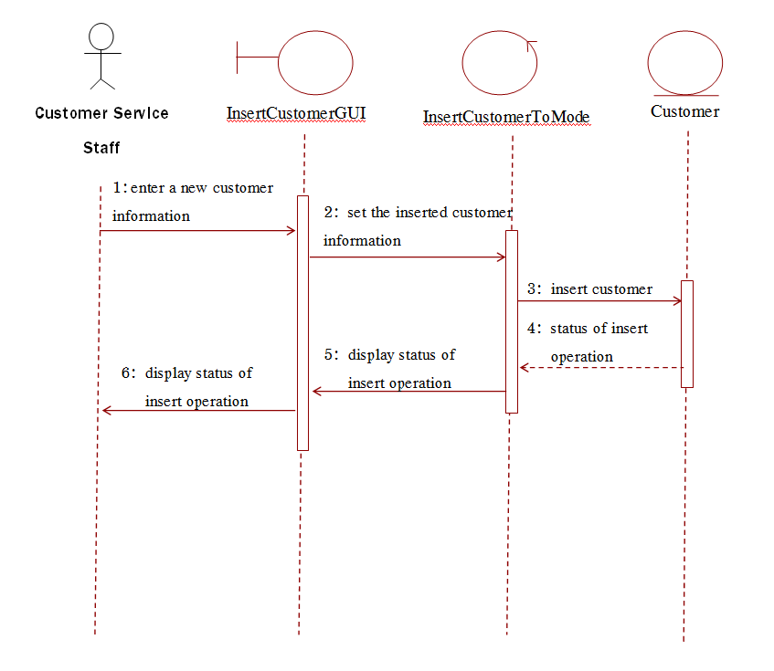

Sequence Diagram demonstrating operation “Update customer”

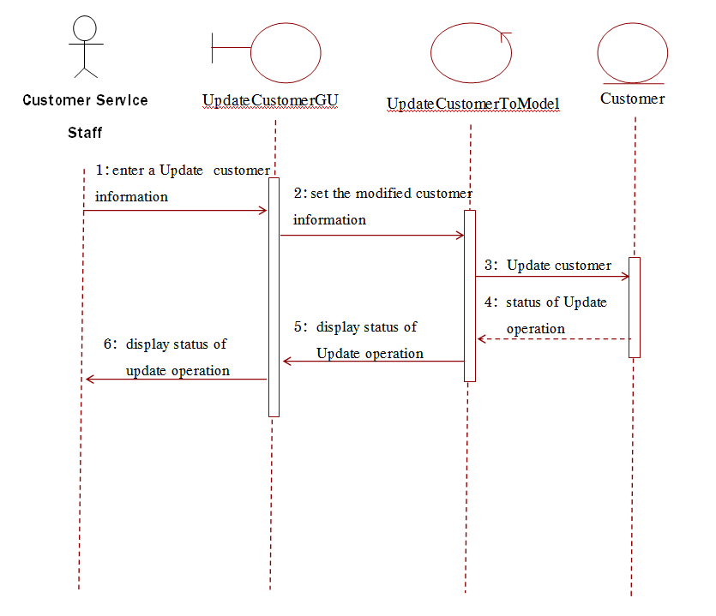

Sequence Diagram demonstrating operation “delete customer”

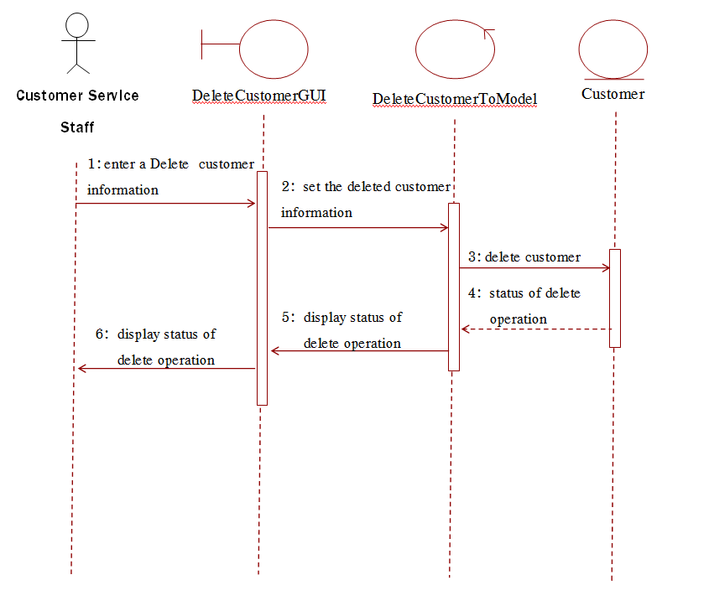

Sequence Diagram demonstrating operation “Report customer”

